Exercise
The purpose of this exercise is:
- To investigate the cause of offset in a P-only controller
- To investigate the cause of oscillations in a PI controller

Open Loop Response
First Order Plus Dead time (FOPDT) model:
$$τ_{p}\frac{dy}{dt}=-y+K_{p}u(t-θ_{p})$$
Where:
- Kp = 2
- τp = 200
- θp = 0

- Simulate the behavior for making a step change in manual mode from 0 to 10 (and back). Explain what happens in terms of oscillations or a smooth response.
Solution
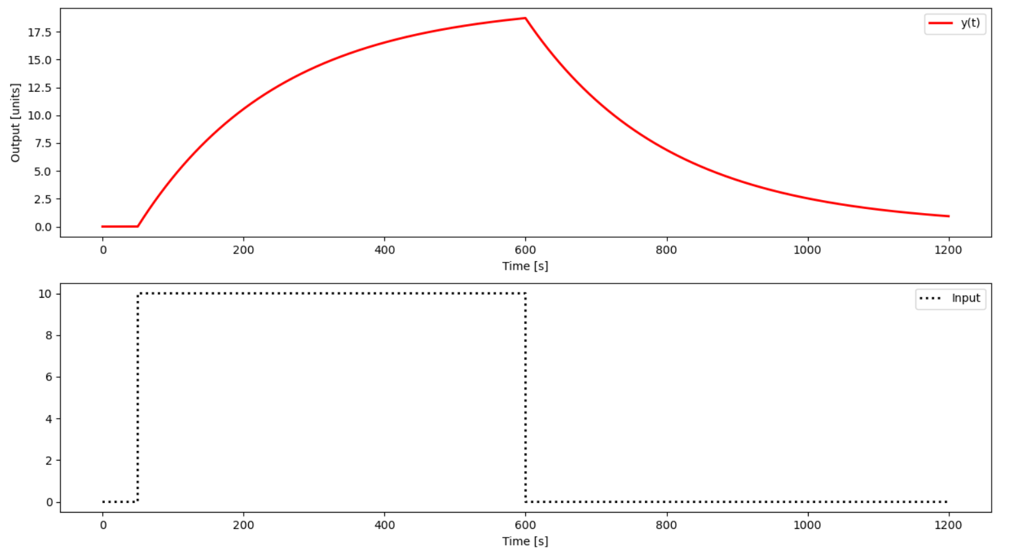

There are no oscillations, the response is smooth.

P-only control
Simulate the behavior for using a P-only controller with:
- Kc=2
- Kc=0.5
Implement a set point change from 0 to 10 and back in automatic mode (closed-loop). Include a plot of the error between the set point (SP) and process variable (PV). What happens with increased Kc in terms of offset and oscillation?
Solution
Kc = 2
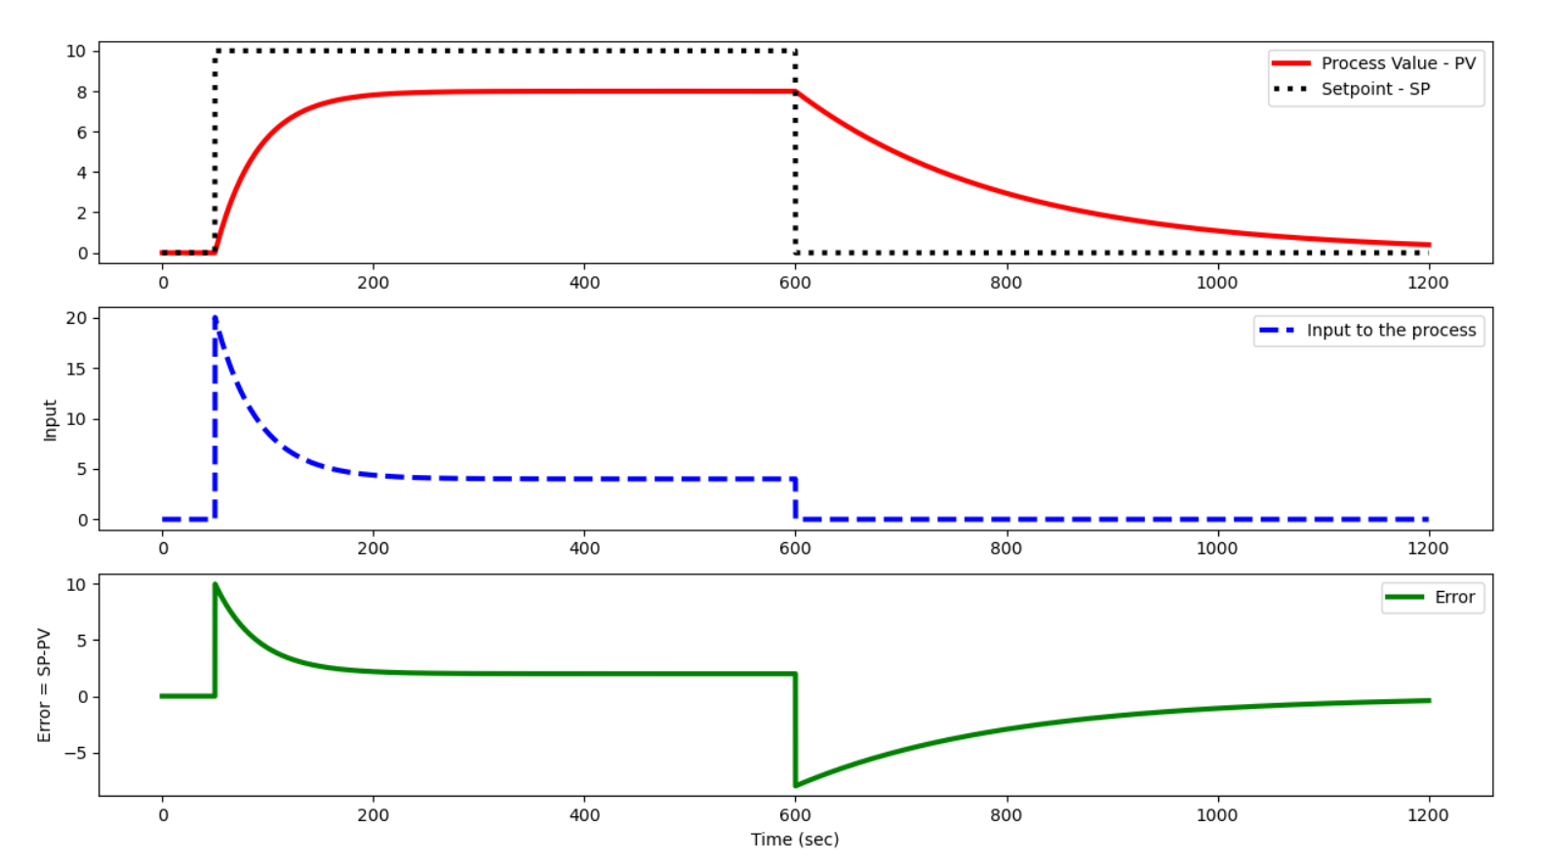

Kc = 0.5
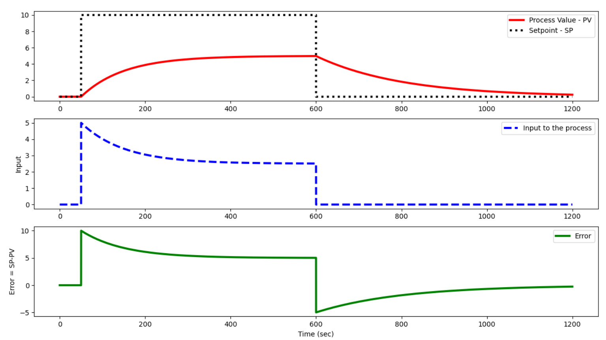

With an increased Kc, the offset is smaller and the final values is reached sooner.

PI control
Configure the controller to add an integral term in addition to the proportional control with:
- Kc = 2
Simulate the PI controller response with integral reset times:
- τI = 200, 100, 10
Include a plot of the integral of the error between the set point (SP) and process variable (PV) with anti-reset windup. Explain what happens and why.
Solution
- Smaller values for the controller's integral time constant produce an increased oscillatory behavior on the output.
- The anti-reset windup prevents and increasing error accumulation when an upper or lower saturation occurs.
τI = 200
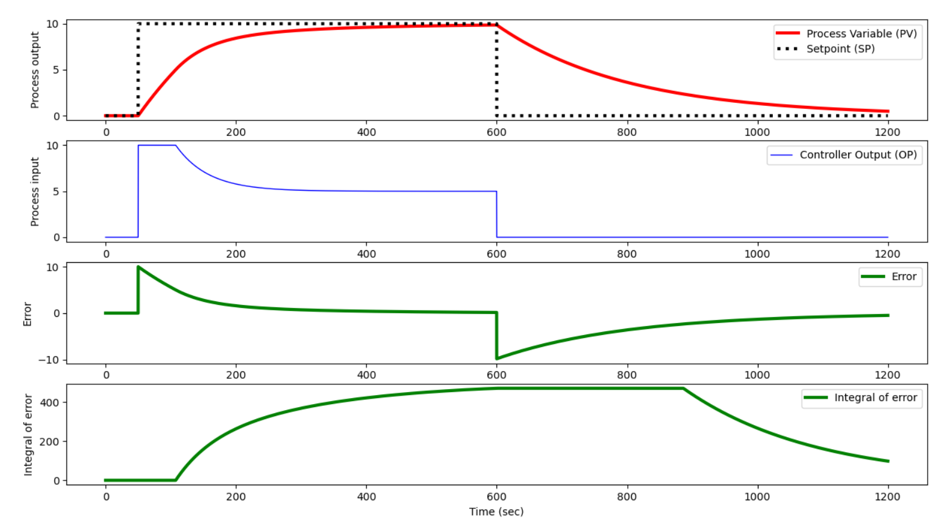
τI = 100
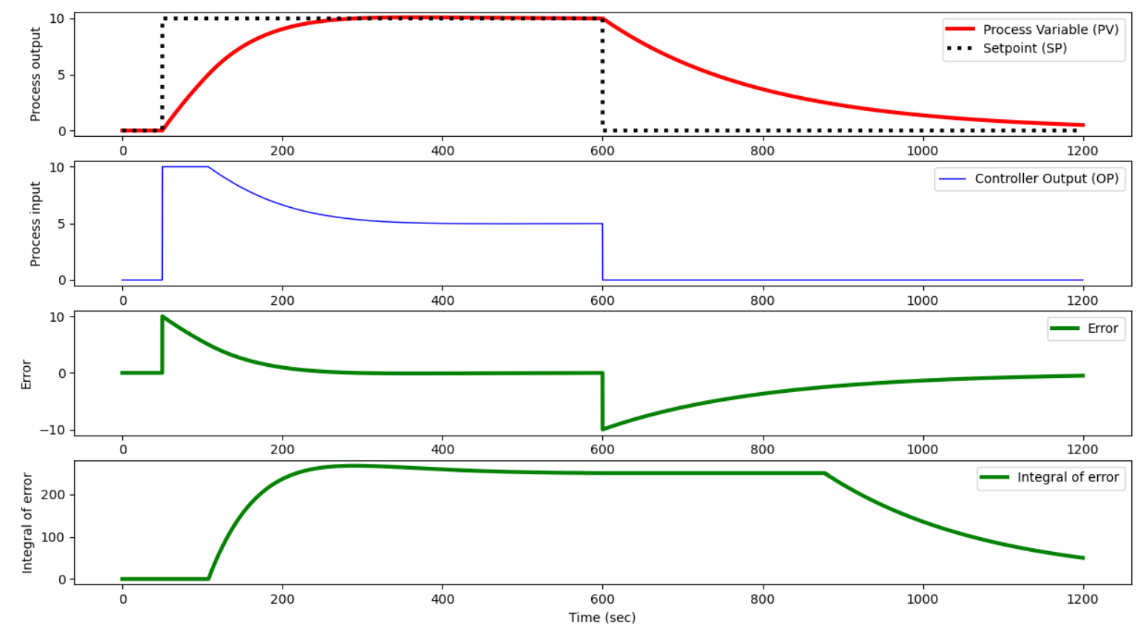
τI = 10
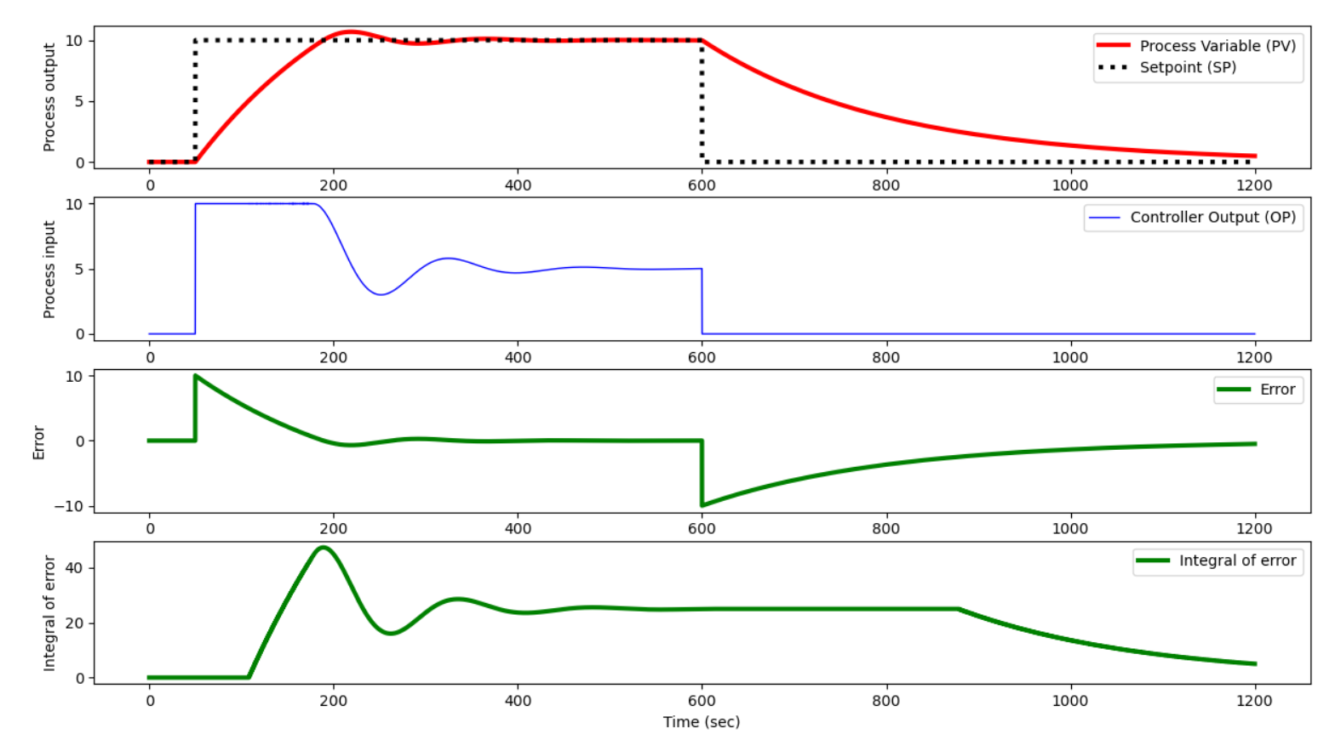
τI = 10 and no anti-windup:
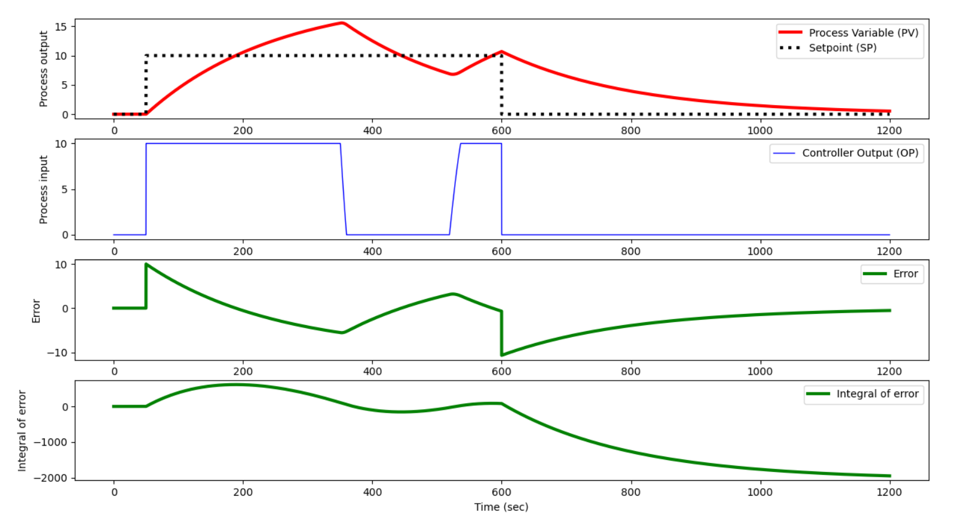

Open Loop Response with Dead Time
Add dead time θp=100 as an input delay. Simulate the behavior for making a step change in manual mode from 0 to 10 (and back). Explain what happens in terms of oscillations.
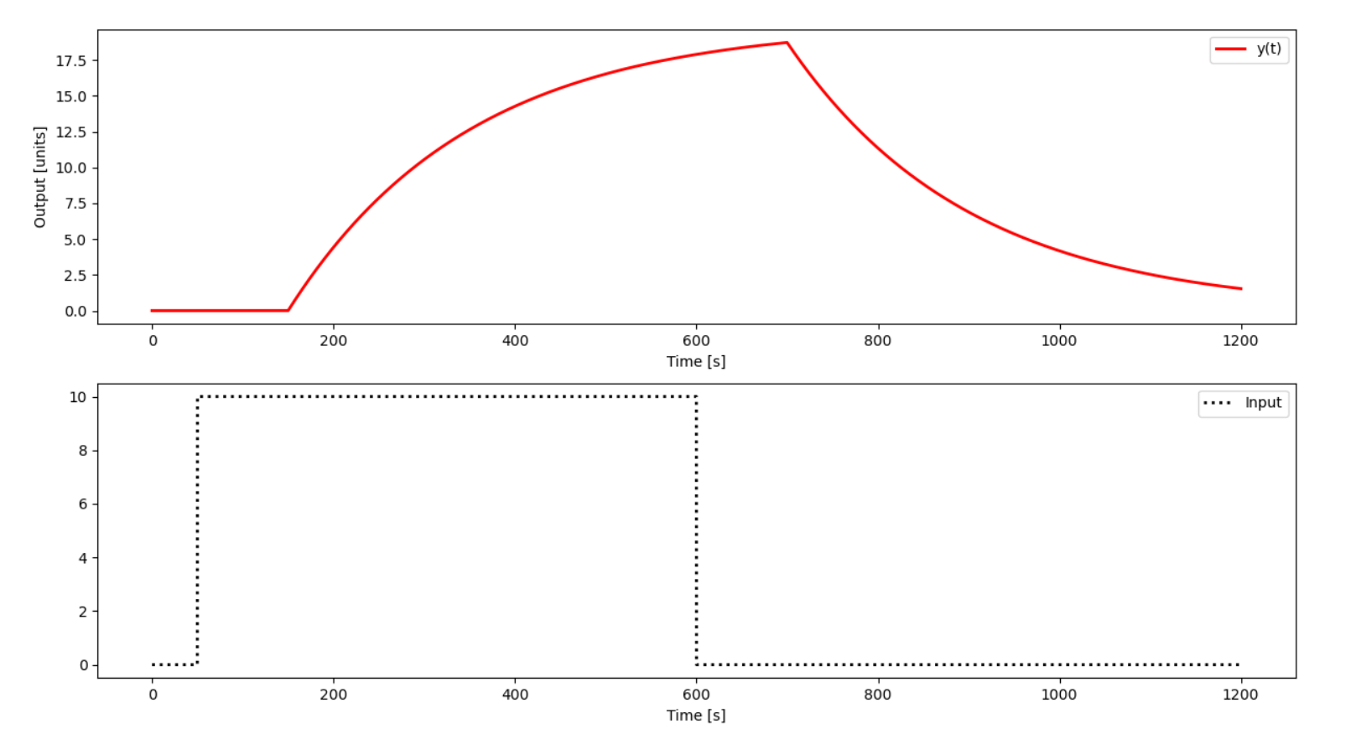
I see no oscillations in the open loop response, only the expected lag.

P-only Control with Dead Time
With the dead time, simulate the response of a P-only controller with:
- Kc=2
- Kc=0.5
Implement a set point change from 0 to 10 and back in automatic mode (closed-loop). Include a plot of the error between the set point (SP) and process variable (PV). What happens with increased Kc in terms of offset and oscillation?
Solution
With Kc = 2:
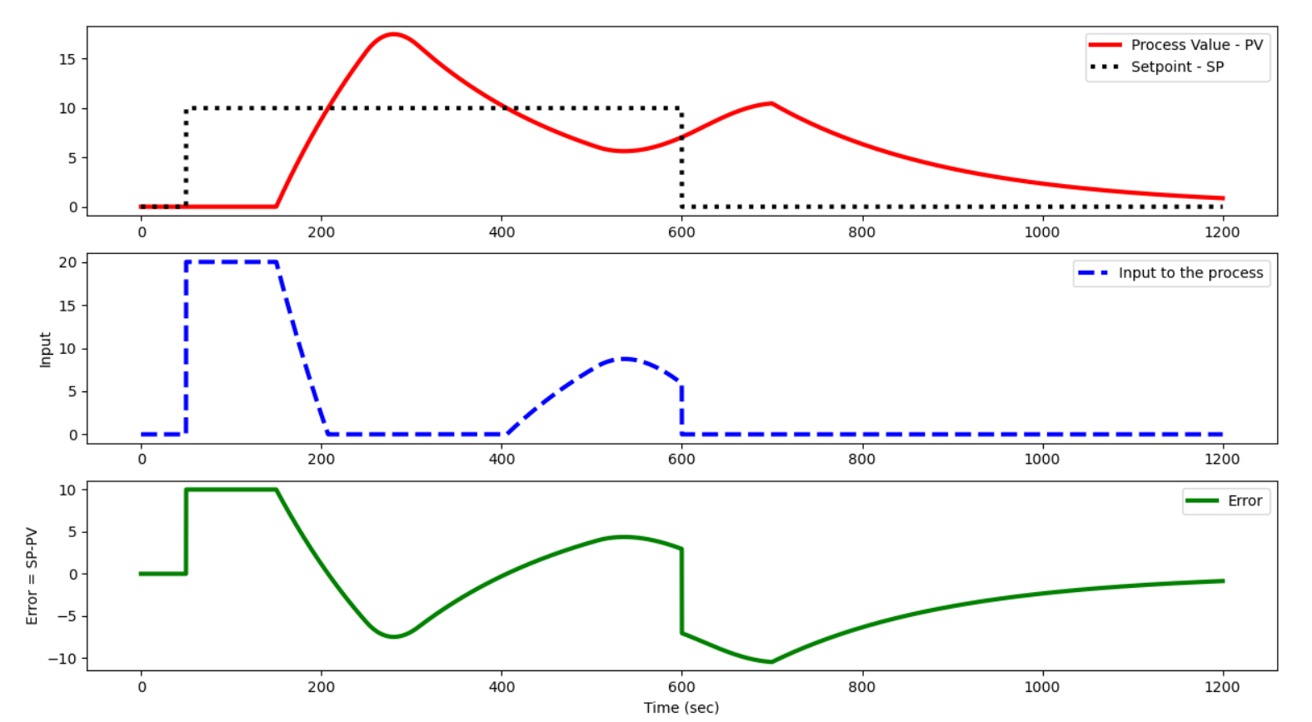
With Kc = 0.5:
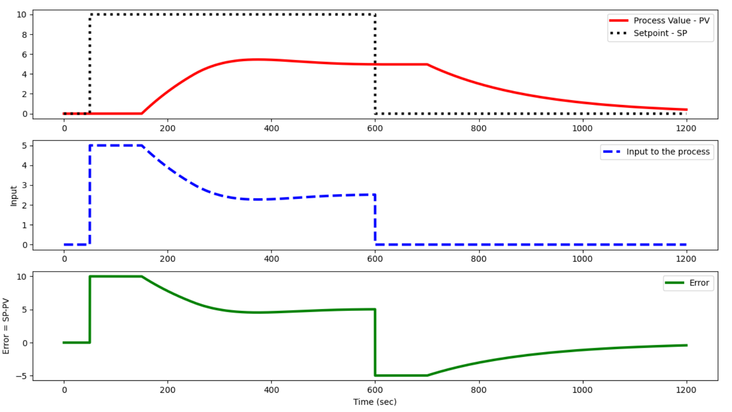
With an increased Kc, the offset diminishes but the oscillations increase.

PI Control with Dead Time
Simulate the response of a PI controller with τI=200. Include a plot of the integral of the error between the set point (SP) and process variable (PV) with anti-reset windup. Explain what happens and why. Explain the results.
Solution

With, Kp = 2, τp = 200, θp = 100 and Kc = 2, τI = 200:

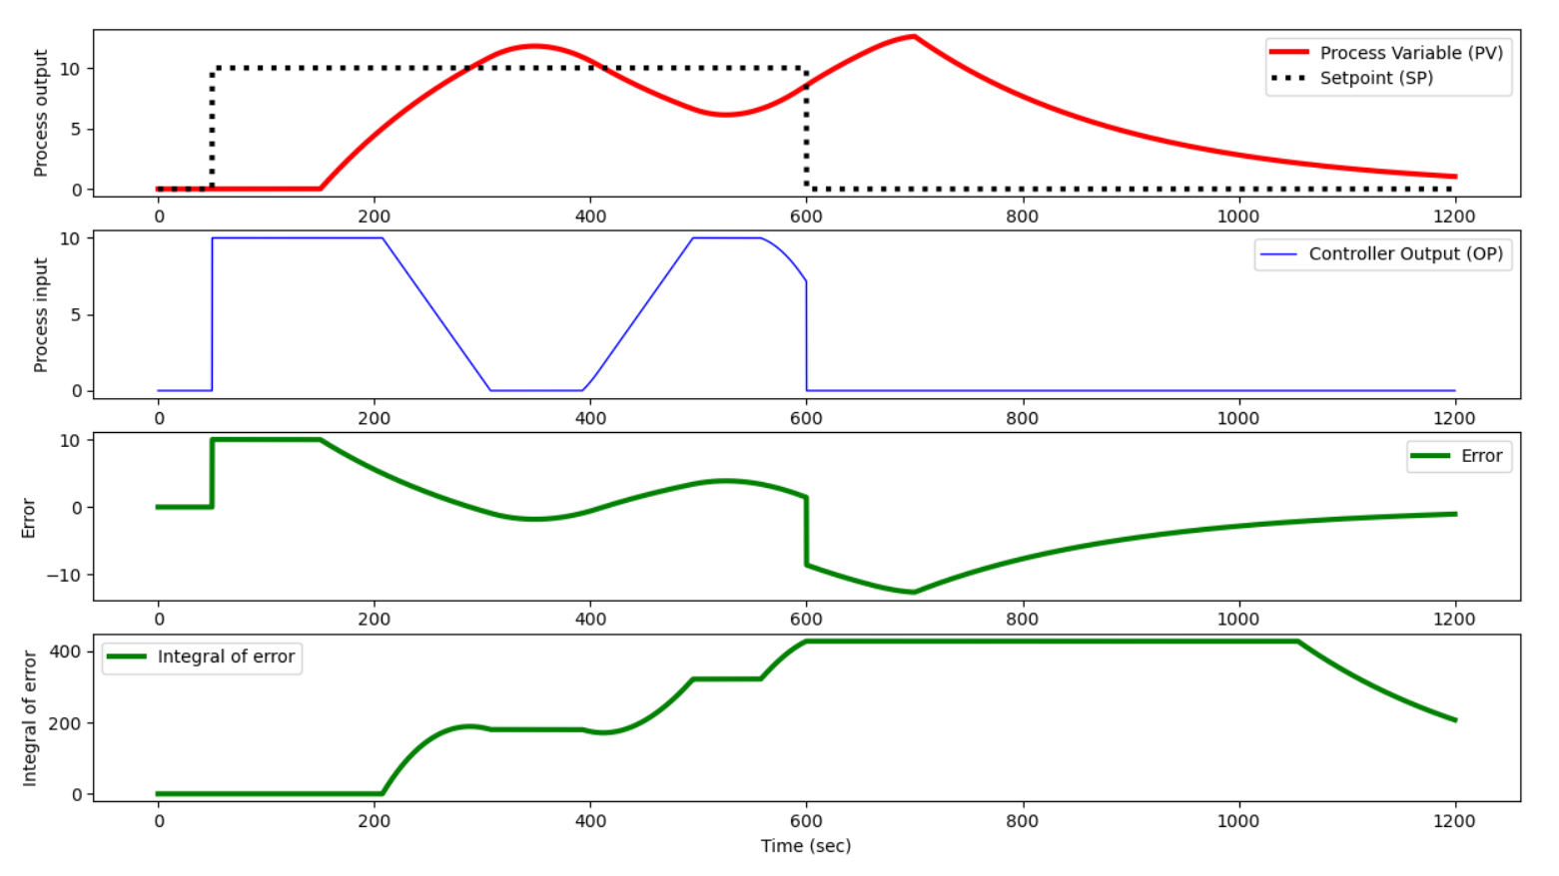
Having a dead time really complicates matters as it adds oscillations. When there was no dead -time and a PI control was used, the response converged without oscillations.

Summary Questions
- Based on the observations in manual mode, is the process stable or unstable?
- Why does P-only control have persistent offset?
- What is the effect of dead time on P-only and PI control?
- If the process is stable, why can the control system make it unstable?
Solution
- The problem seems to be stable as the output is bounded.
- P-only control has persistent offset only when the process is non-integrative.
- Dead time produces oscillations when in closed-loop.
- I don’t know.

